**KSFC Design Document**

**US#001 –** View Primary/Collateral Security under Legal Documentation Loan accounts.

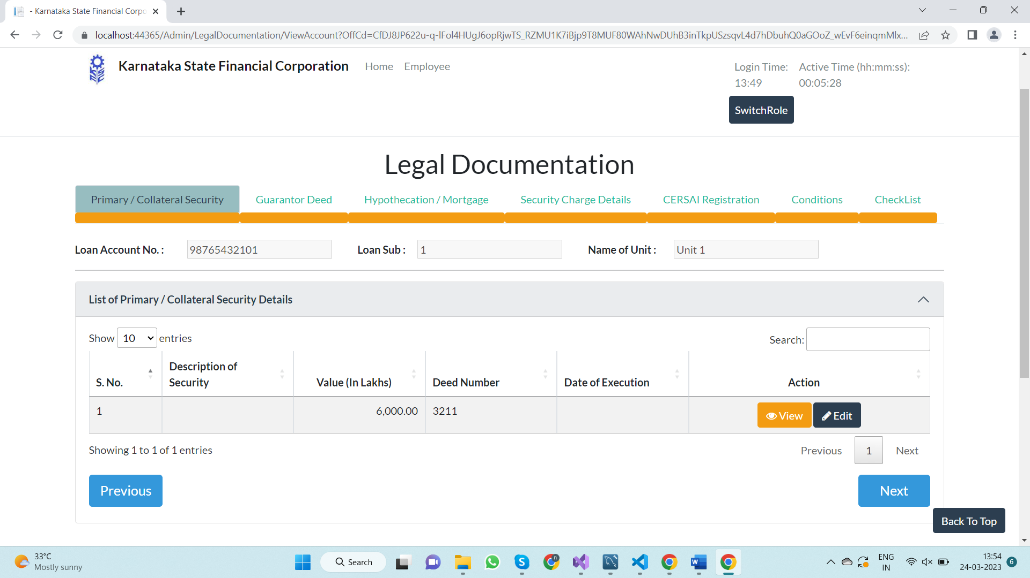

**1.1– Design Decision**

* Create New Progress bar with title **“Primary/Collateral Security”.**
* Under that UI view the list of Primary/Collateral Security Details.

**1.2 – implementation**

* Add Primary/Collateral Security progress Bar in Legal Documentation.
* Create a table to view list of Primary/Collateral Security Details.
* [D:\KSFC\UI\KAR.KSFC.UI\Areas\Admin\Views\LegalDocumentation\ViewAccount.cshtml]

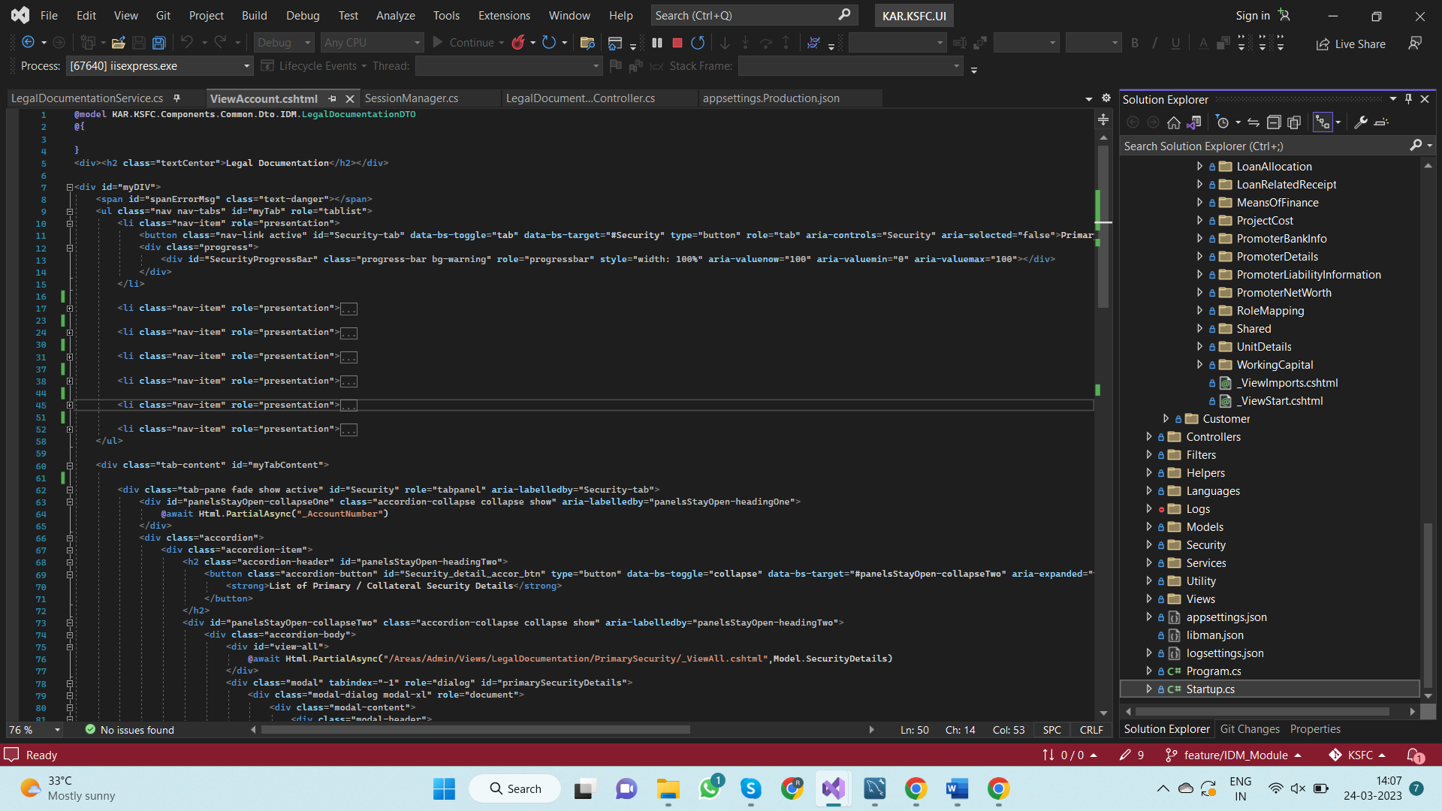

**1.2.1 – Create Models For the Views**

* Create “**TblIdmDeedDet”** Model and add to DbContext

[D:\KSFC\Components\Data\KAR.KSFC.Components.Data.Models\DbModels\TblIdmDeedDet.cs]

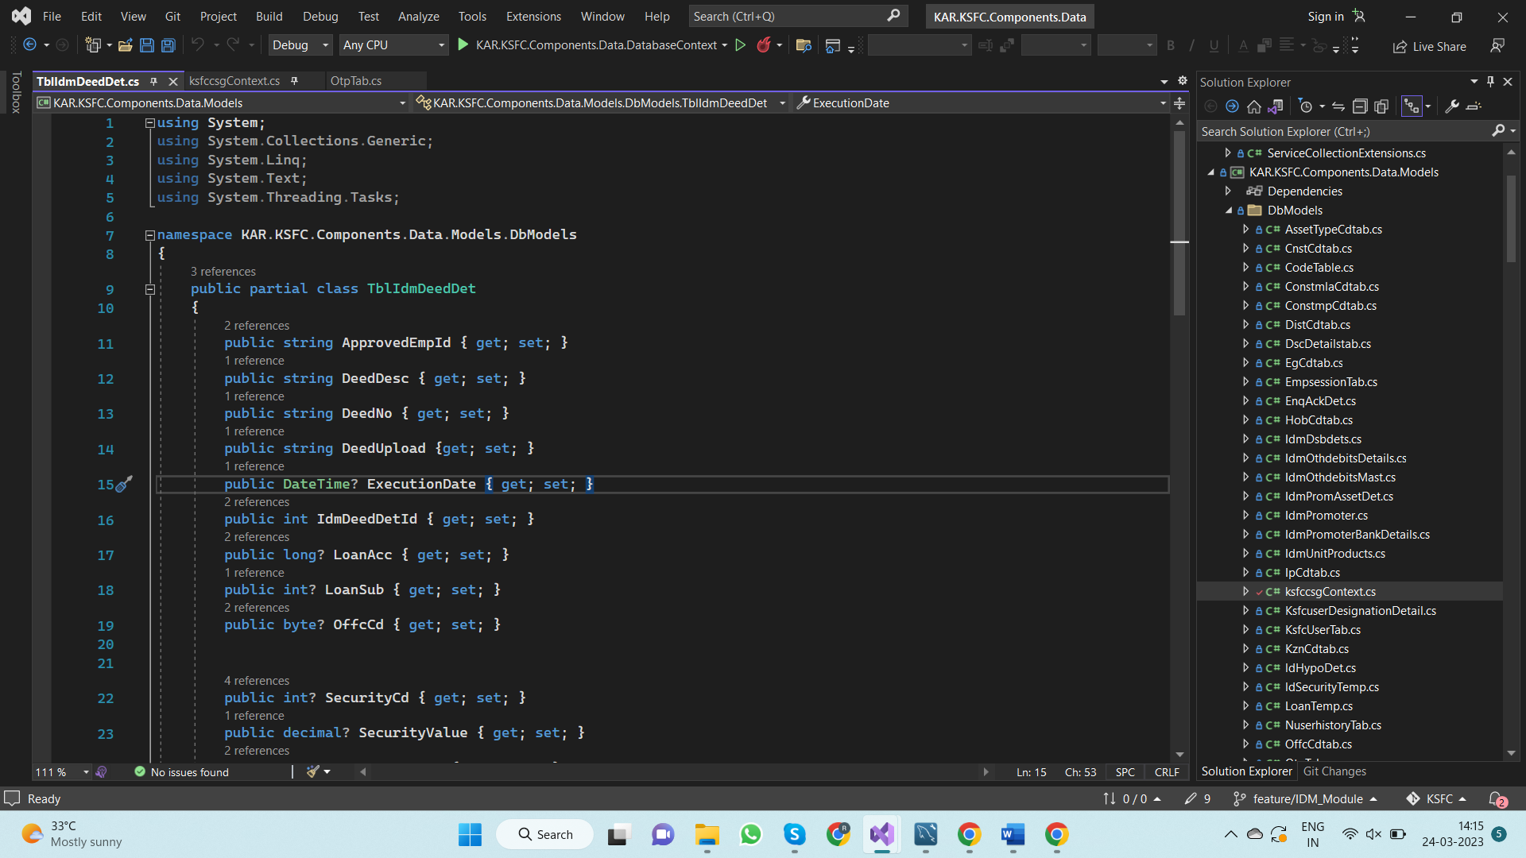

[D:\KSFC\Components\Data\KAR.KSFC.Components.Data.Models\DbModels\ksfccsgContext.cs]

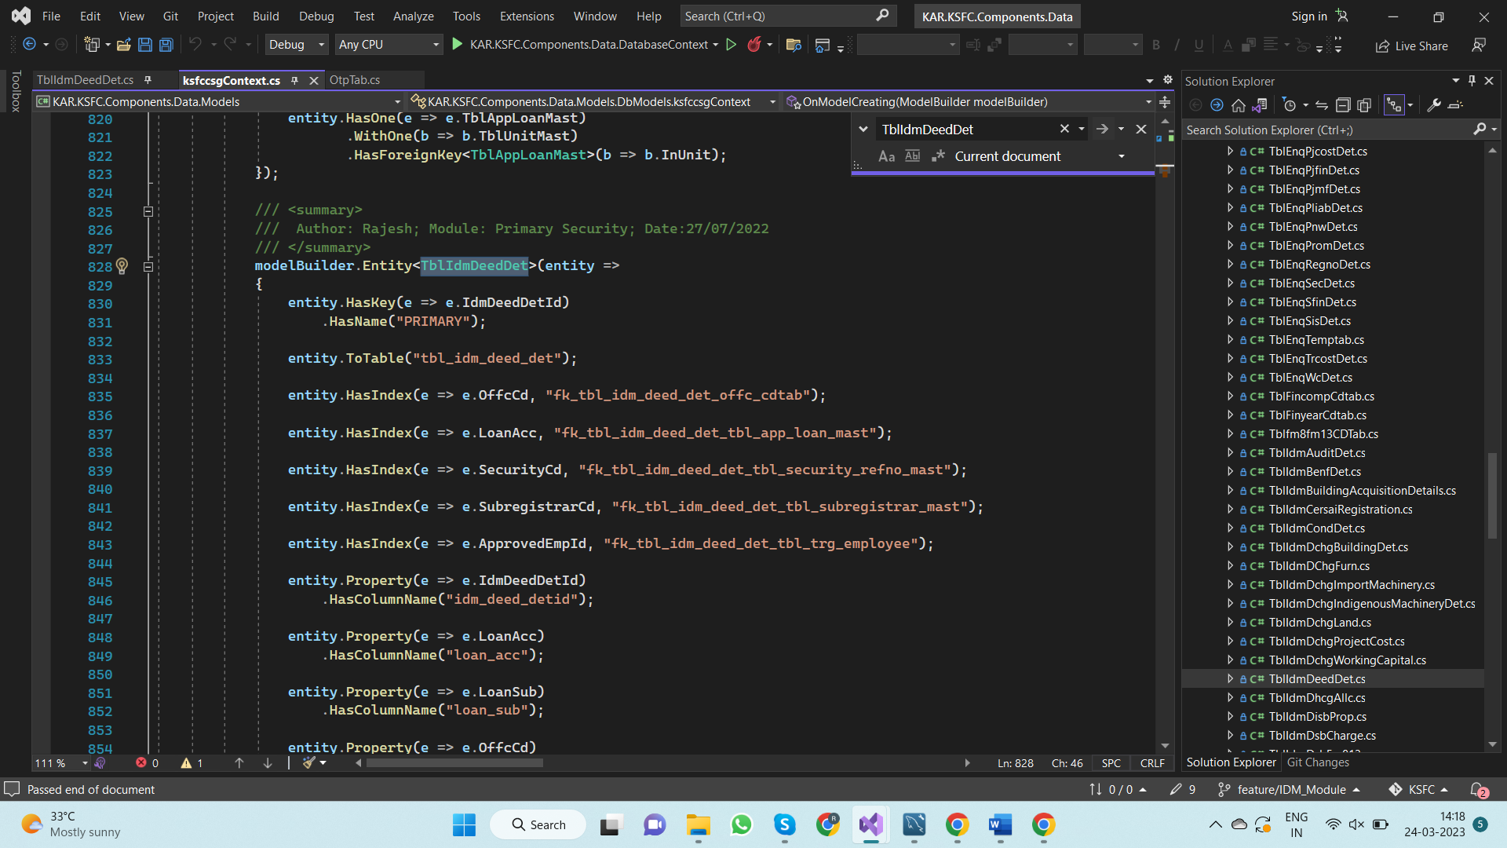

* Create Corresponding DTO for the above model and add them to auto mapper.

[D:\KSFC\Components\Common\KAR.KSFC.Components.Common.Dto\IDM\IdmSecurityDetailsDTO.cs]

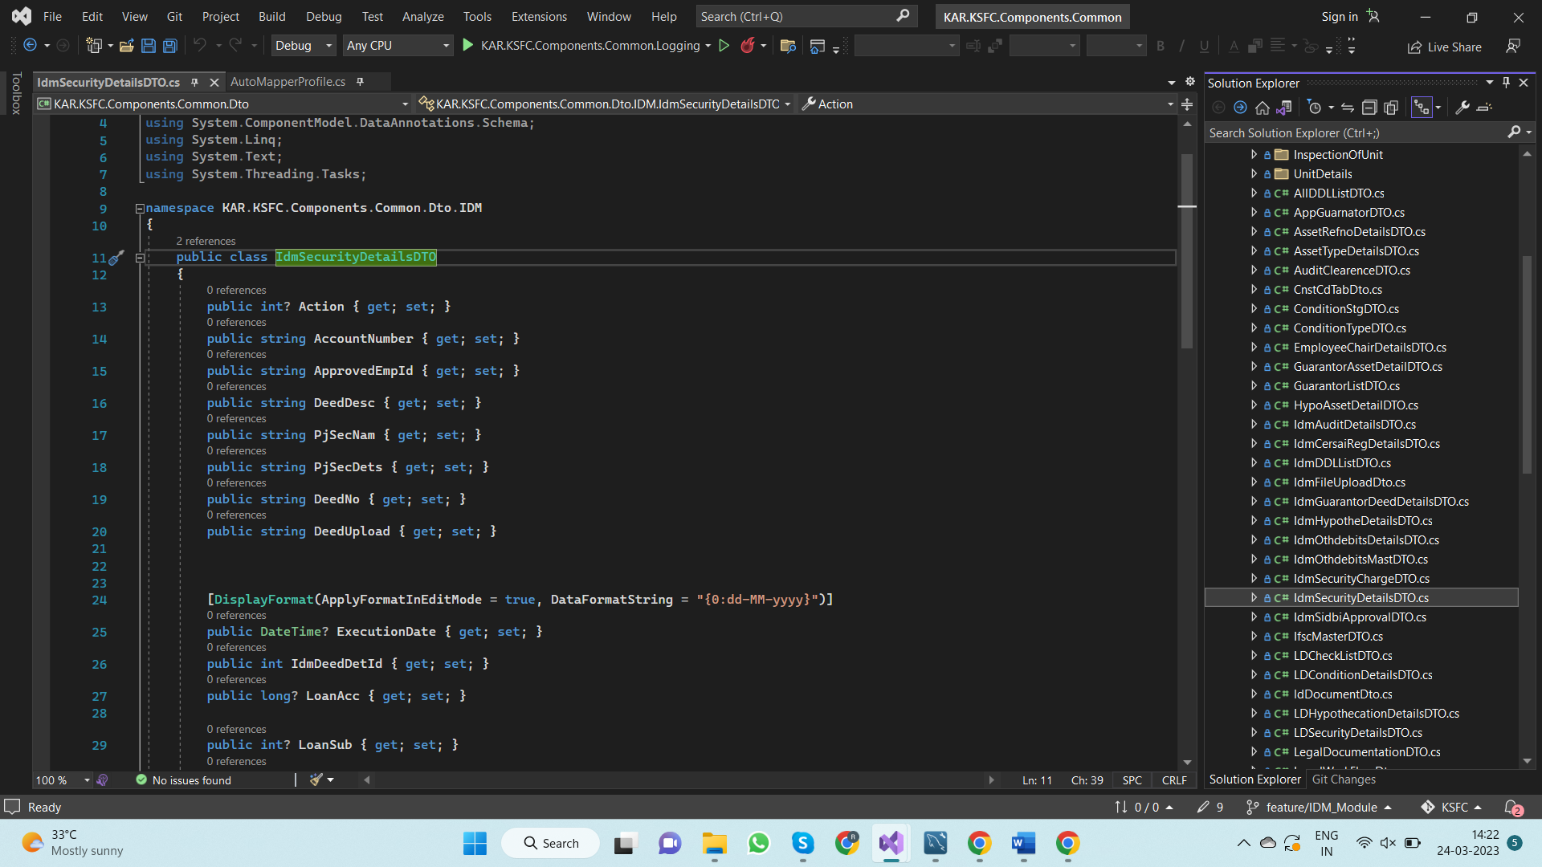

[D:\KSFC\Components\Common\KAR.KSFC.Components.Common.Utilities\MapperProfile\AutoMapperProfile.cs]

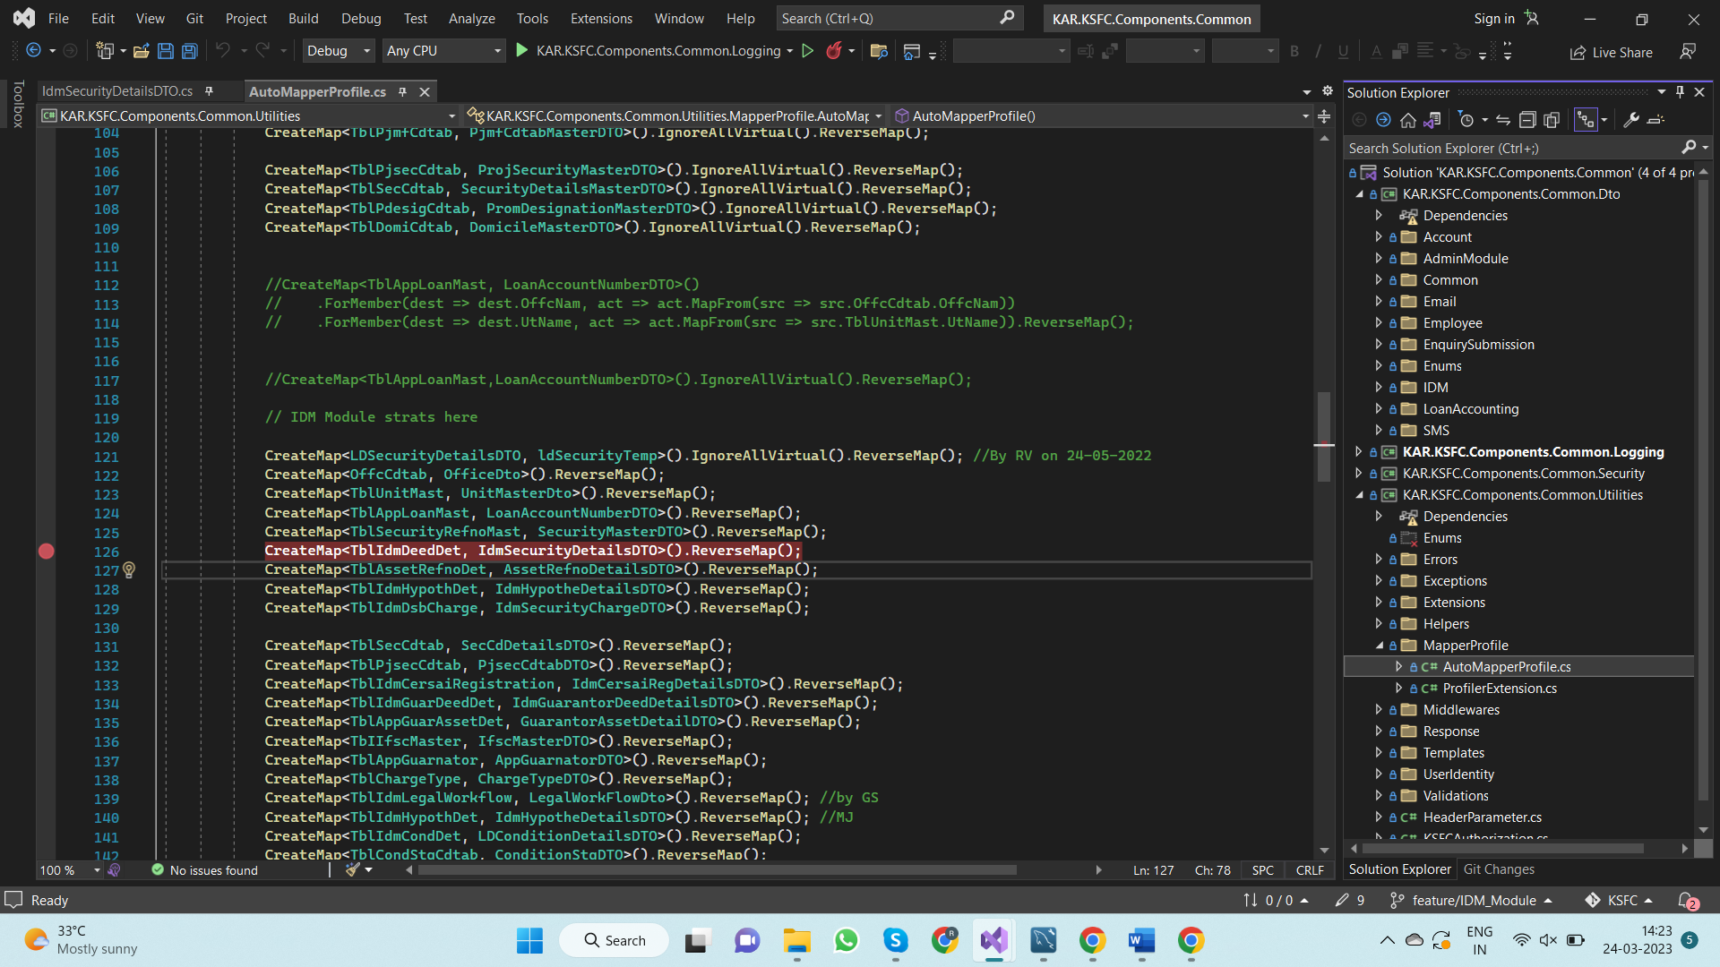

**1.2.2 – Create API method the returns Collateral list**

* Create method named“**GetPrimaryCollateralListAsync” in “ILegalDocumentationService”** interface and implement that method in “**LegalDocumentationService”** Class

[D:\KSFC\API\KAR.KSFC.API.ServiceFacade\Internal\Interface\IDMModule\LegalDocumentationModule\ILegalDocumentationService.cs]

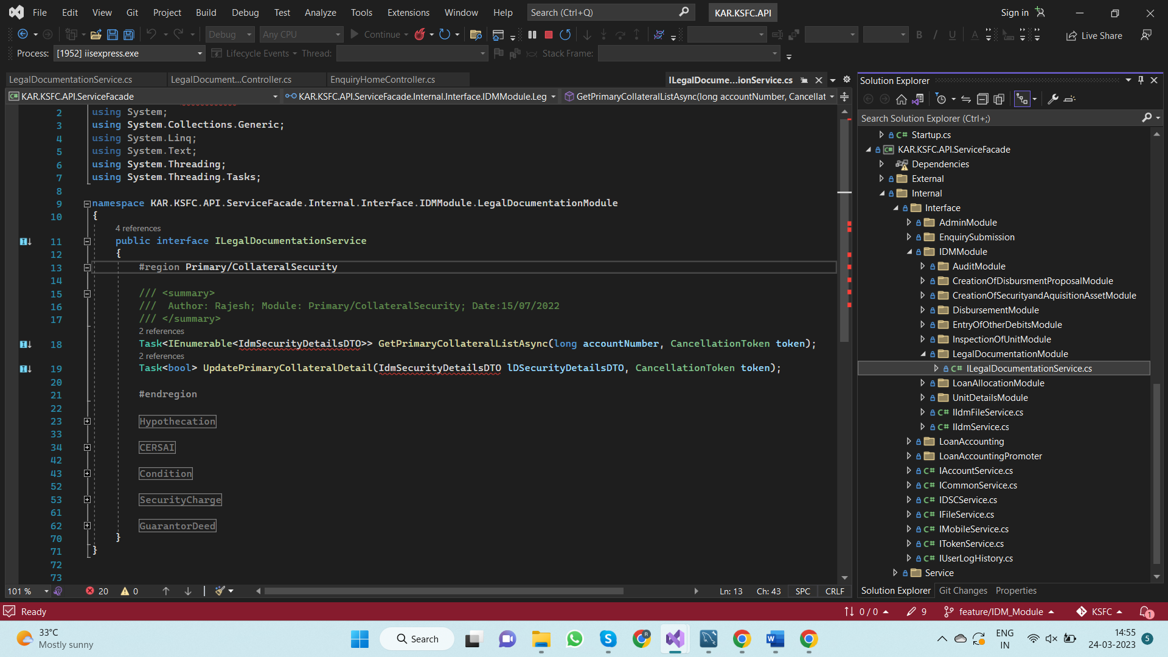

[D:\KSFC\API\KAR.KSFC.API.ServiceFacade\Internal\Service\IDMModule\LegalDocumentationModule\LegalDocumentationService.cs]

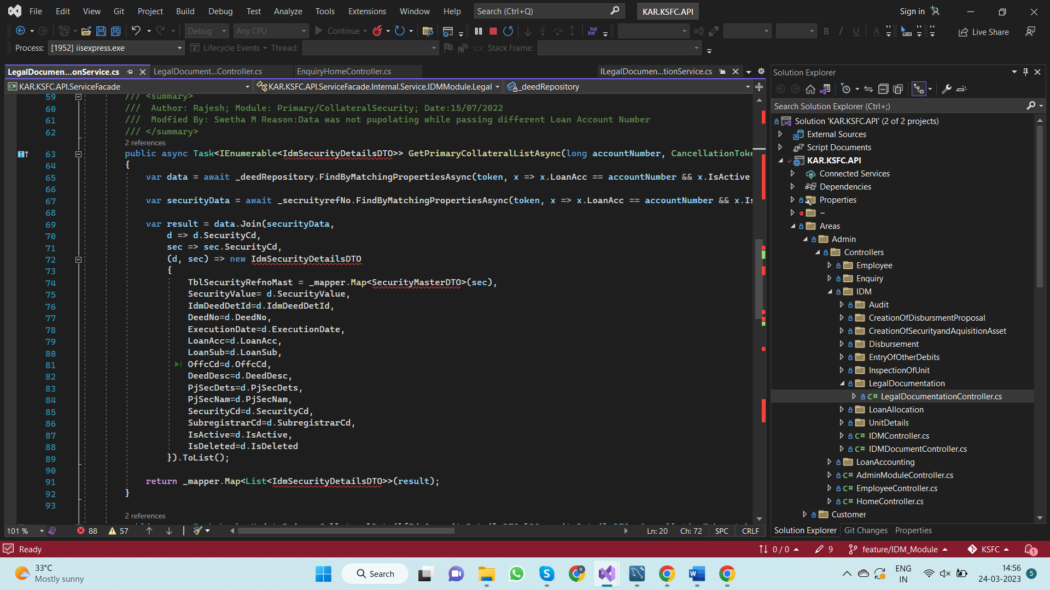

* Create a method name **“GetAllSecurityHolders”** in **“LegalDocumentationController”** and Call the above method.

[D:\KSFC\API\KAR.KSFC.API\Areas\Admin\Controllers\IDM\LegalDocumentation\LegalDocumentationController.cs]

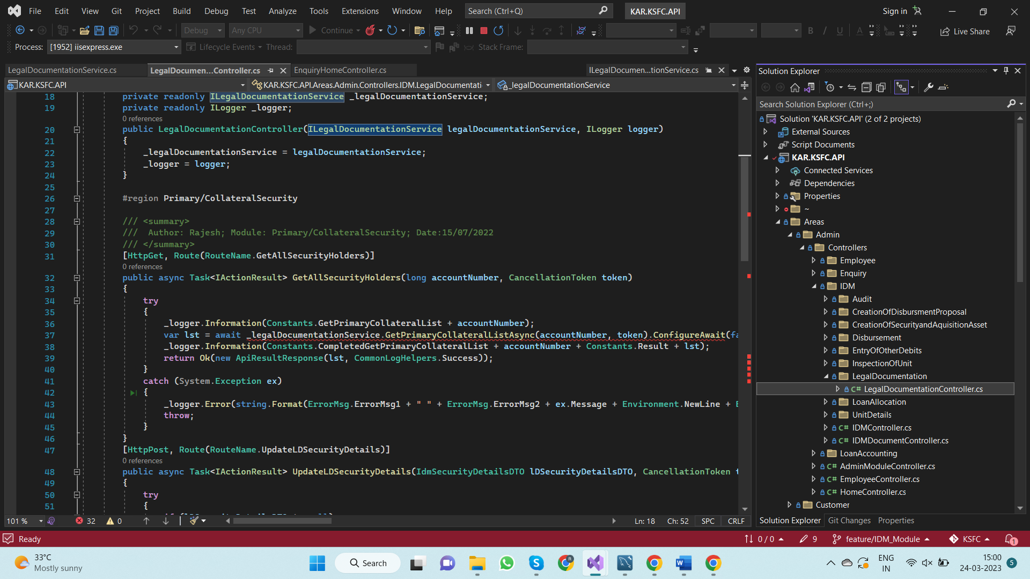

**1.2.2 – Create method in service layer that calls the above API Endpoints**

* Create method named“**GetAllPrimaryCollateralListAsync” in “ILegalDocumentationService”** interface and implement that method in “**LegalDocumentationService”** Class

[D:\KSFC\UI\KAR.KSFC.UI\Services\IServices\Admin\IDM\ILegalDocumentationService\ILegalDocumentationService.cs]

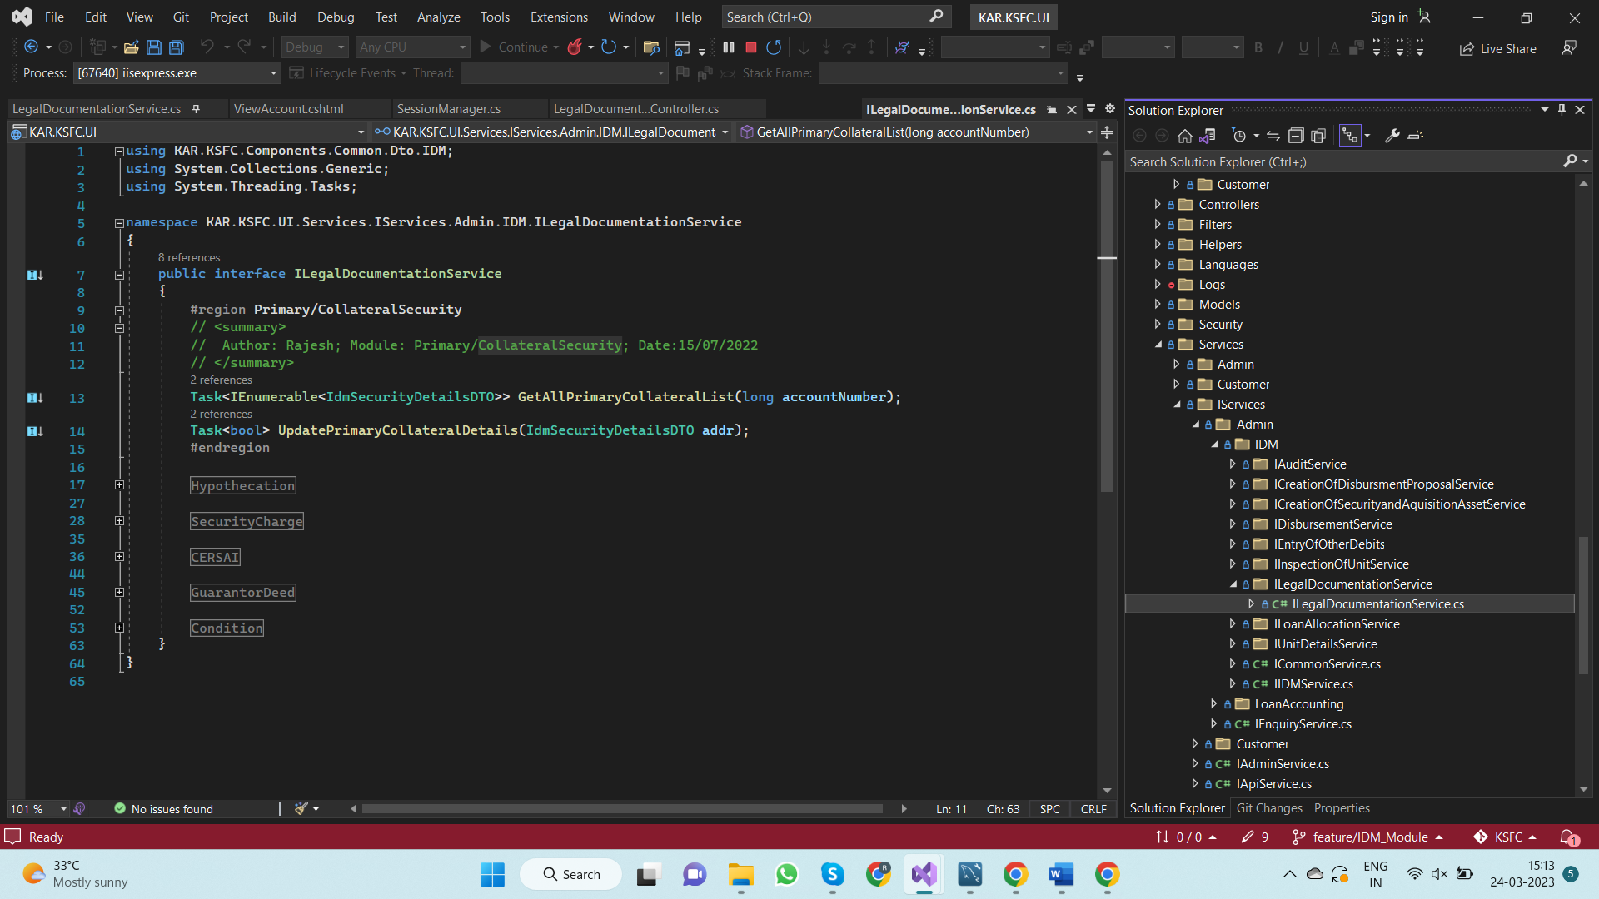

[D:\KSFC\UI\KAR.KSFC.UI\Services\Admin\IDM\LegalDocumentationService\LegalDocumentationService.cs]

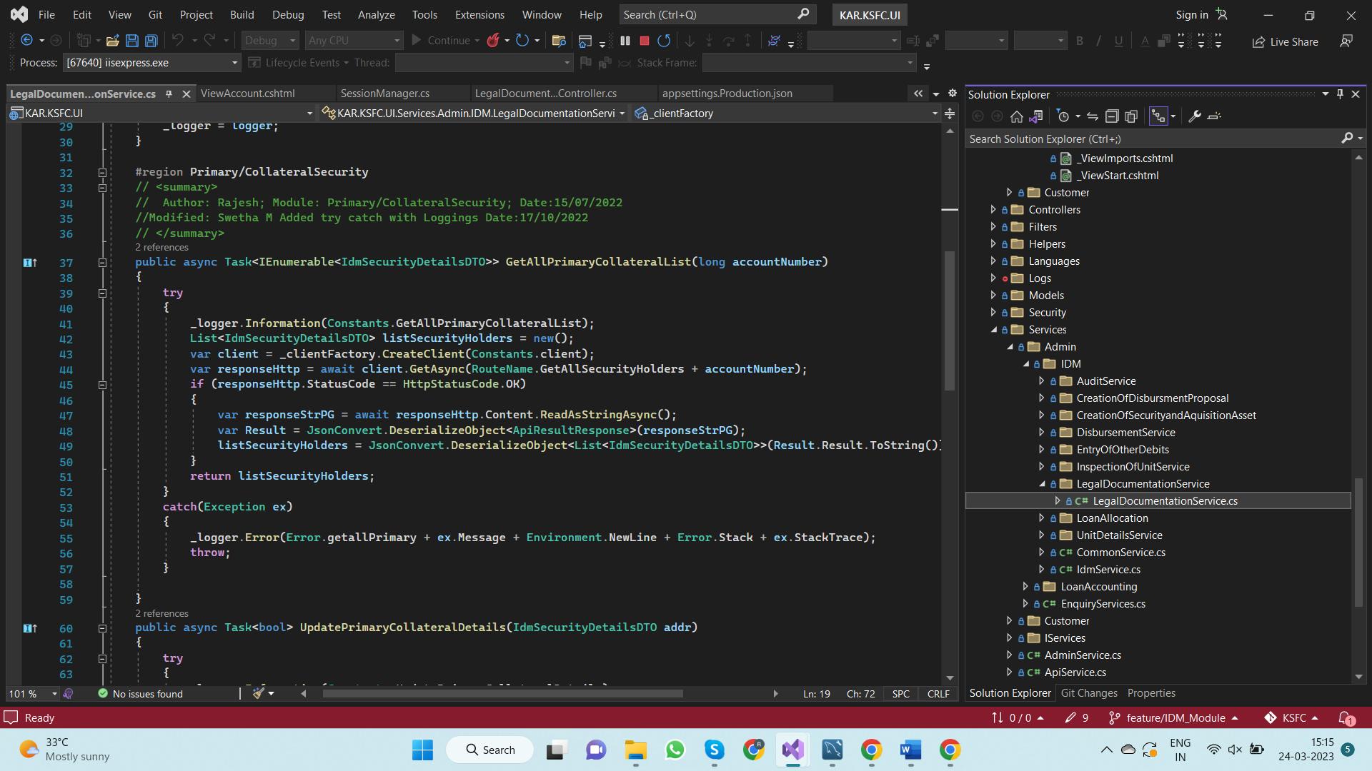

* Call the above methods in **“ViewAccount”** method of the **“LegalDocumentationController**” and return the result to view

[D:\KSFC\UI\KAR.KSFC.UI\Areas\Admin\Controllers\IDM\LegalDocumentation\LegalDocumentationController.cs]

